**SWE363-BE1**

**BE1-Exerecise1:**

* <https://www.google.com/>
* 142.251.37.196:443
* 74 requests
* Document, script, png, stylesheet, webp, ping, xhr, fetch, text/html, font, x-icon
* largest size (56.2 kB)
* 305 ms.

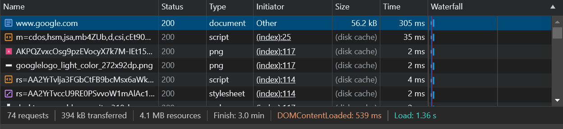

**BE2-Exercise 2:**

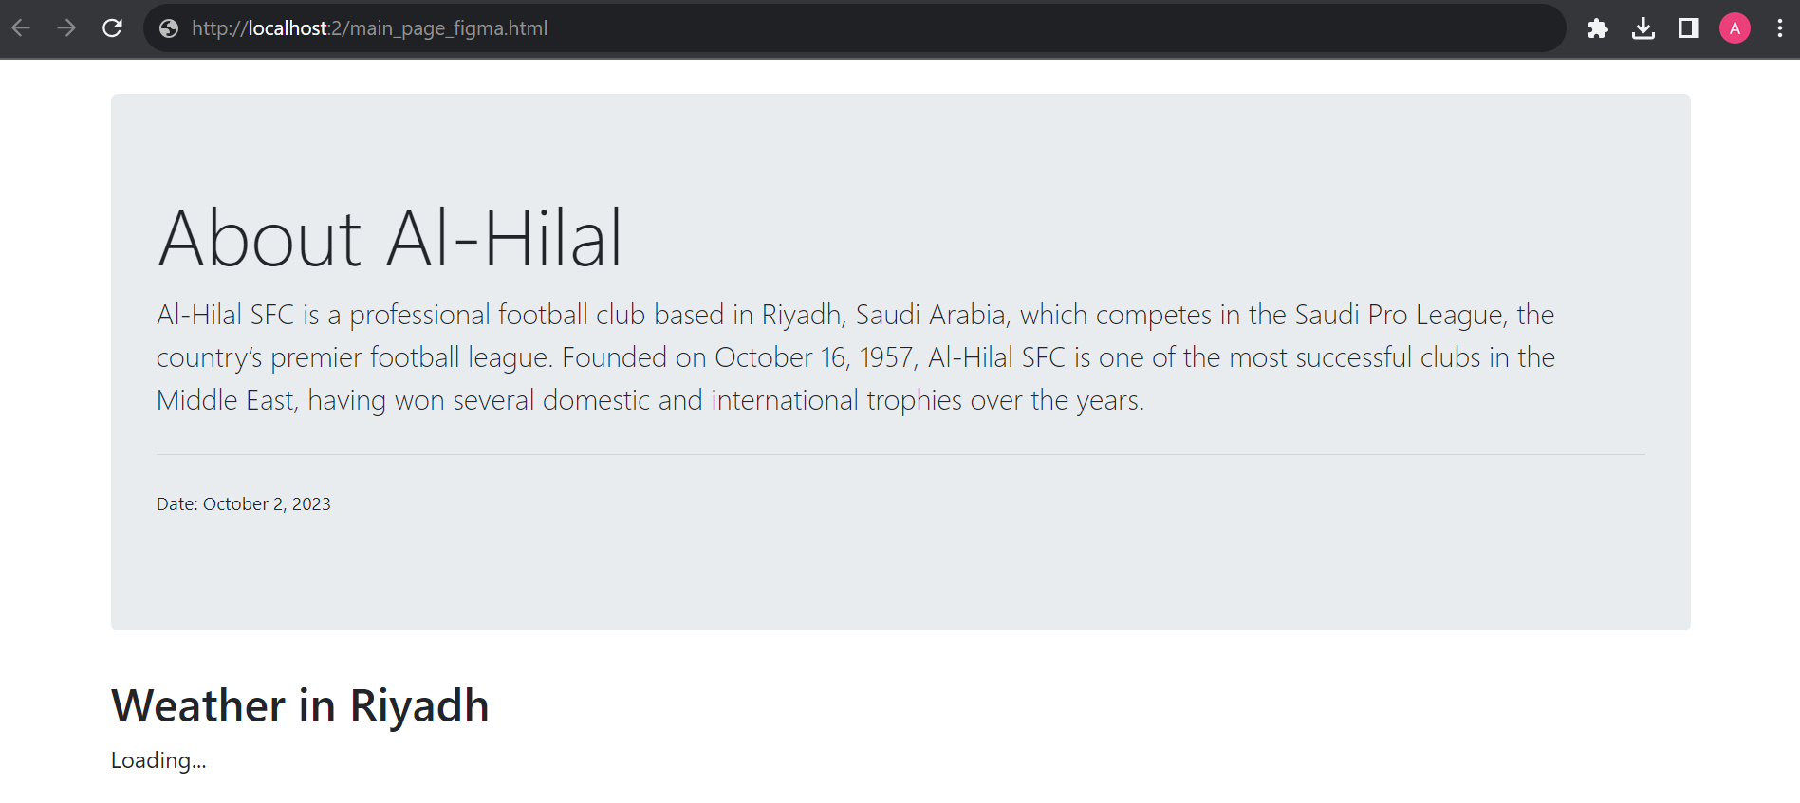

**BE1-Exercise 3:**

domain name: alhilal.website